CSE 581

**Lab 1: Database Account Setup**

a.

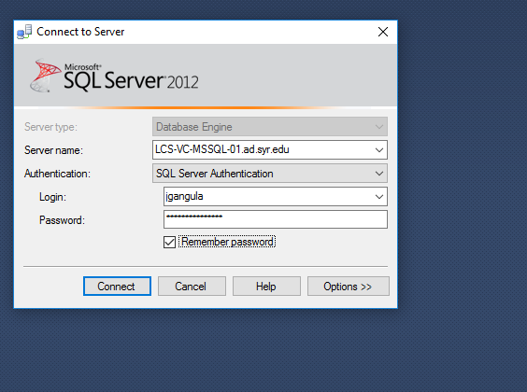

**b.**

